21.6 EPSDT System Flowcharts

The following section contains EPSDT Subsystem process flowcharts. The flowcharts included in this section are:

- 21.6.1 Daily Adjudicated Claims Extract – NMME0105
- 21.6.2 Detail Table Maintenance – NMME0100
- 21.6.3 Monthly Client Extract – NMME0200
- 21.6.4 Newly Eligibile Notice Letter and Roster – NMME1000
- 21.6.5 Medical Notice Letter and Roster – NMME2000
- 21.6.6 Medical Past-Due Notice Letter and Roster – NMME2500
- 21.6.7 Dental Notice Letter and Roster – NMME5000
- 21.6.8 Blood Lead Notice Letter and Roster – NMME6000
- 21.6.9 FTP Letters For Postal Pros – NMME7000
- 21.6.10 CMS-416 EPSDT Participation Report – NMME8000
- 21.6.11 Identify Clients Over 28 Years Old – NMME9300
- 21.6.12 Delete Clients Over 28 From EPSDT Tables – NMME9400

21.6.1 Daily Adjudication Extract – NMME0105

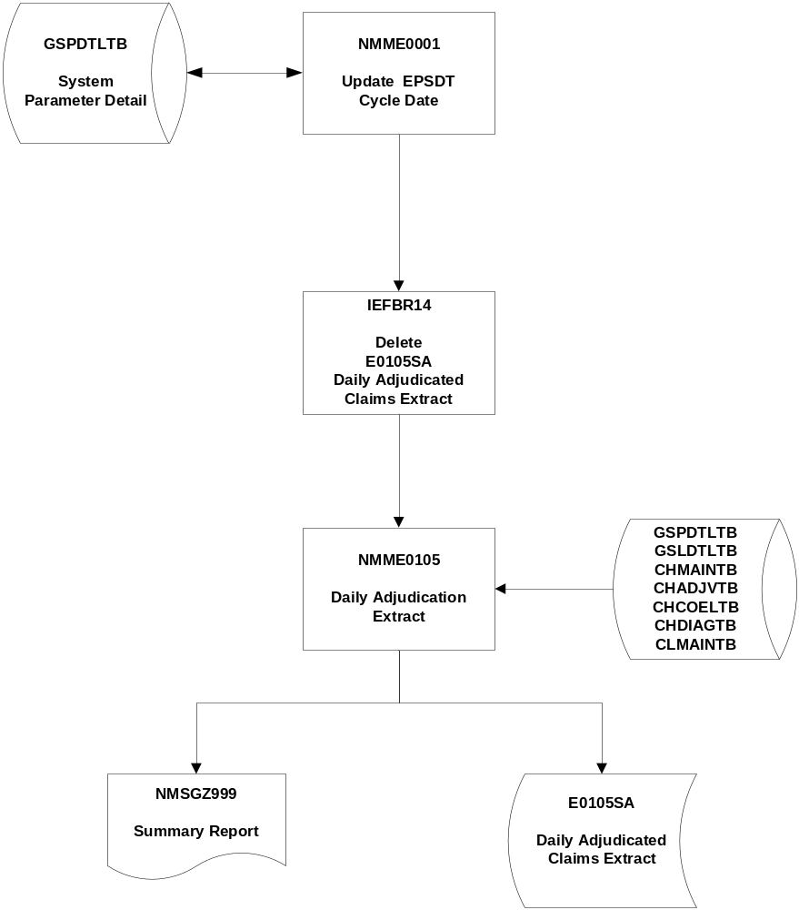
21.6.2 Detail Table Maintenance – NMME0100

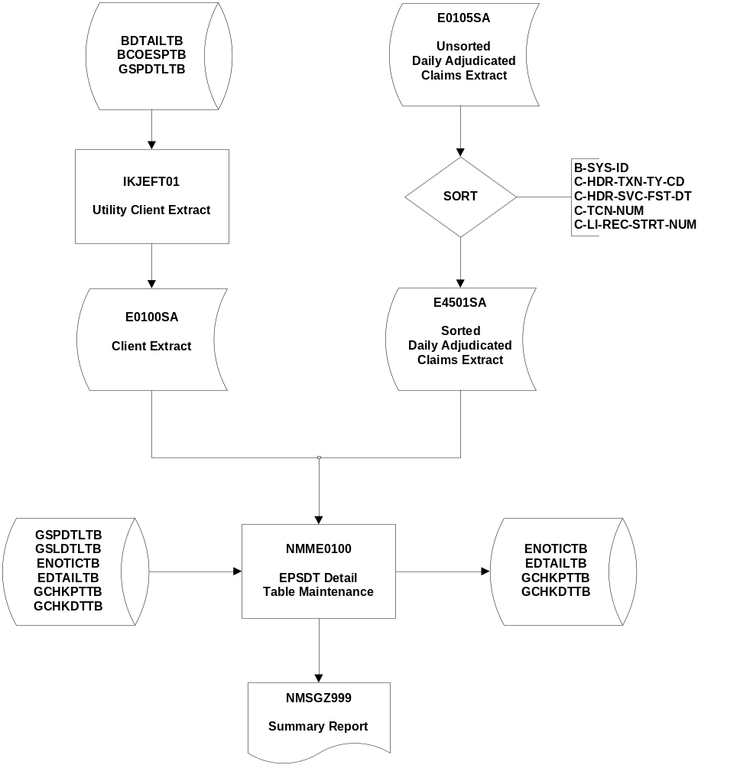
21.6.3 Monthly Client Extract – NMME0200
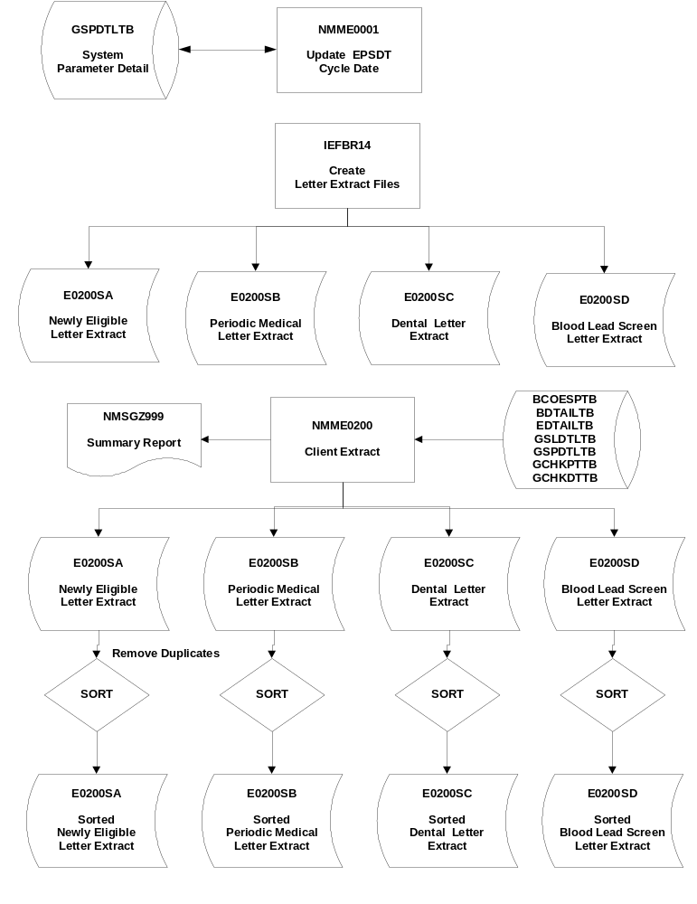
21.6.4 Newly Eligible Notice Letter and Roster – NMME1000

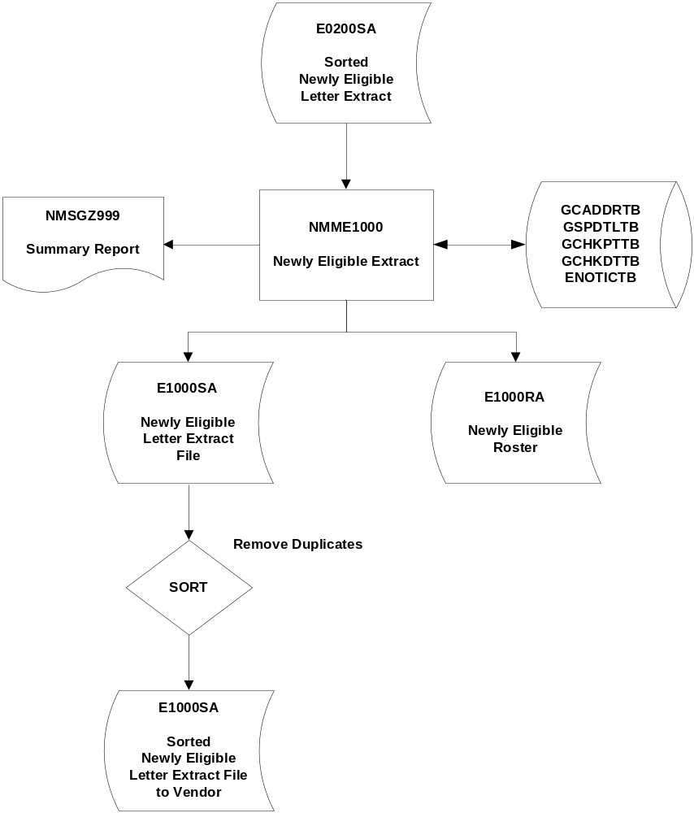
21.6.5 Medical Notice Letter and Roster – NMME2000

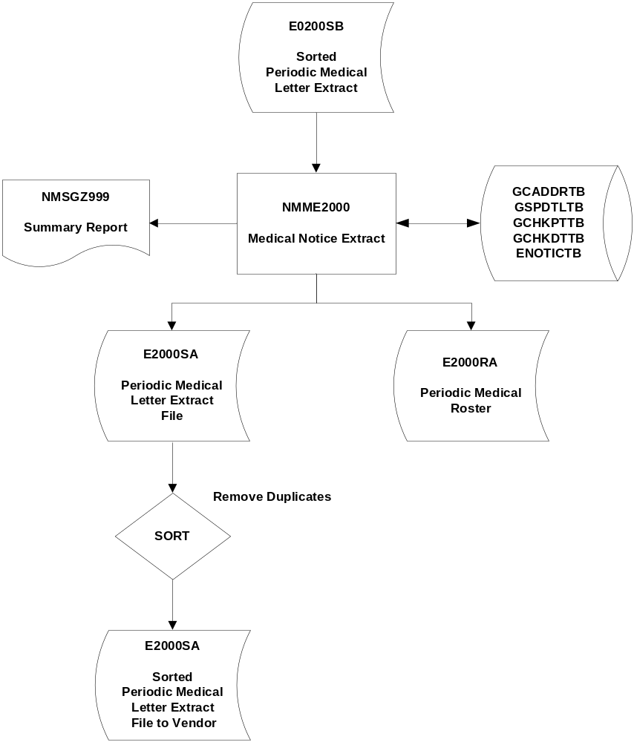
21.6.6 Medical Past-Due Notice Letter and Roster – NMME2500

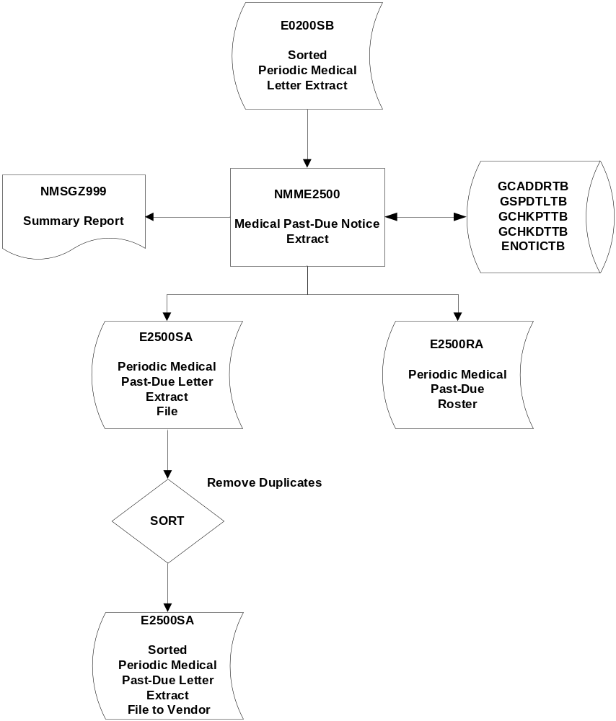
21.6.7 Dental Notice Letter and Roster – NMME5000

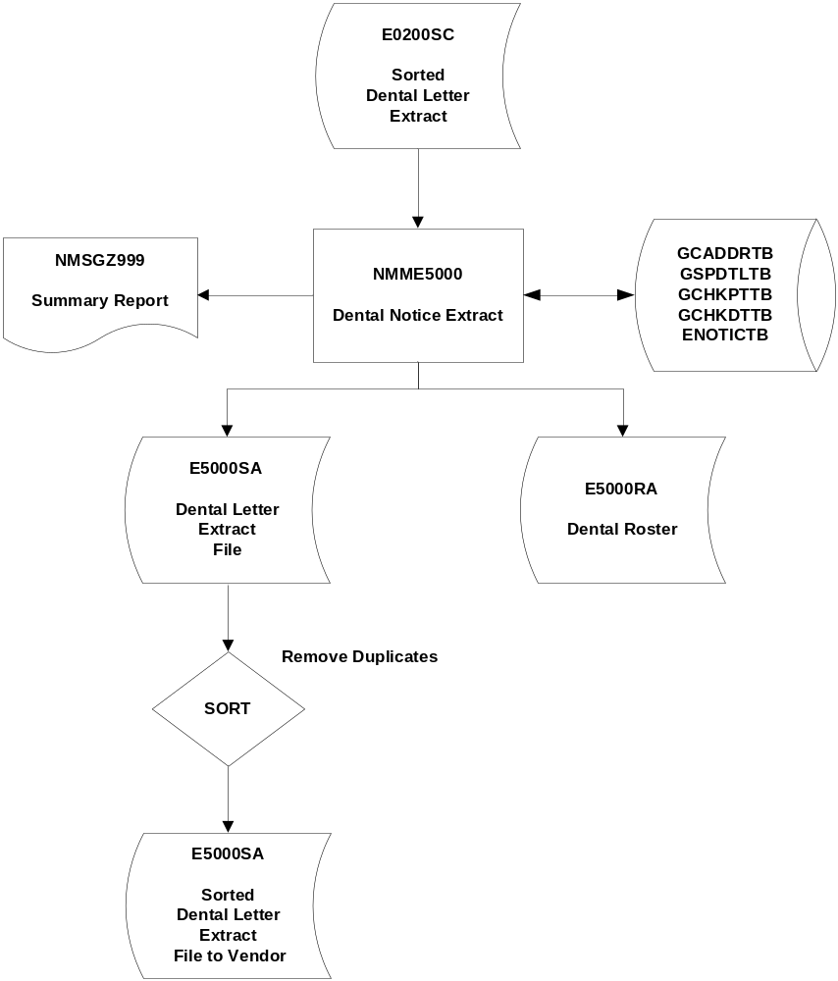
21.6.8 Blood Lead Notice Letter and Roster – NMME6000

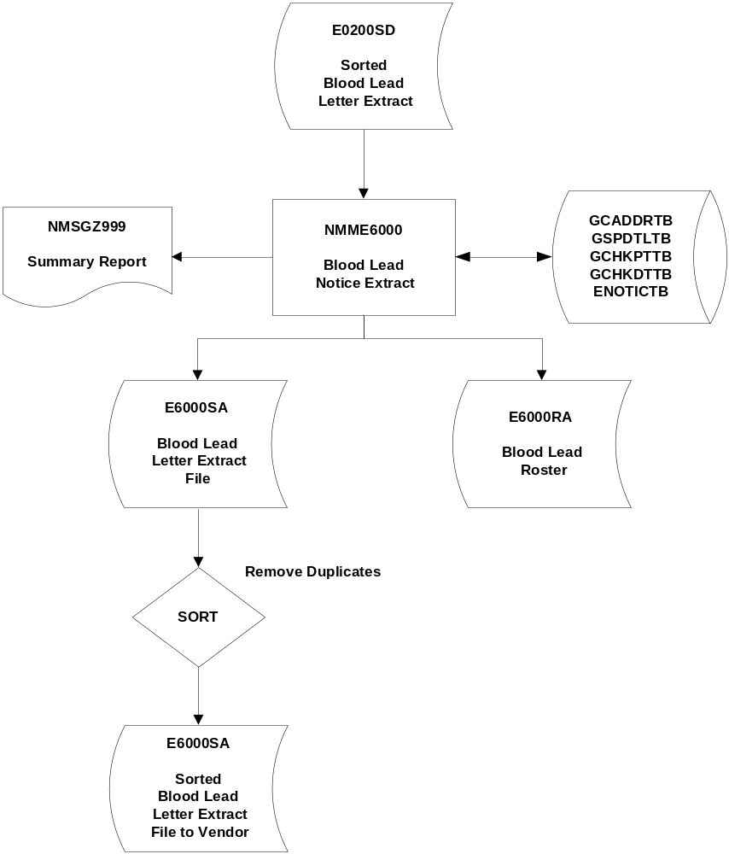
21.6.9 FTP Letters For Postal Pros – NMME7000

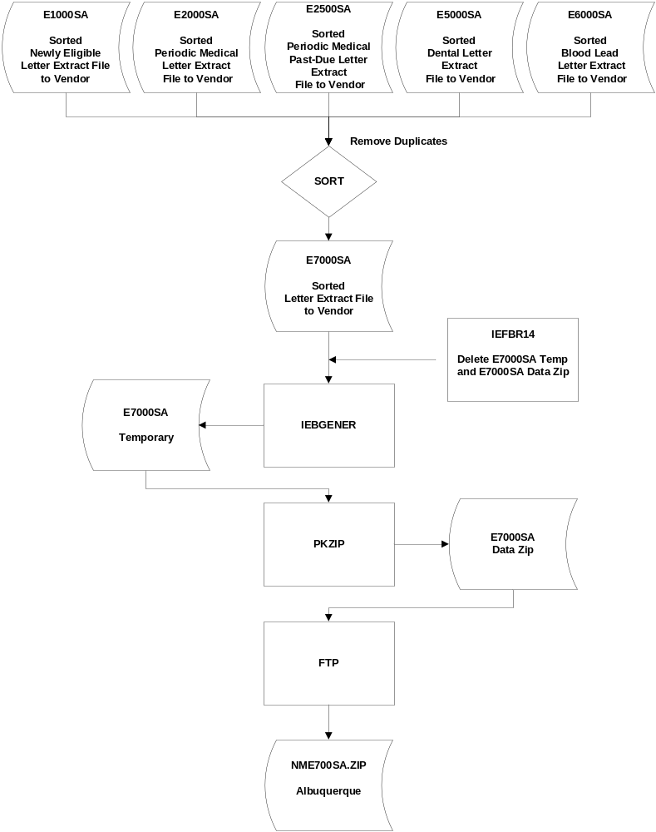
21.6.10 CMS-416 EPSDT Participation Report – NMME8000

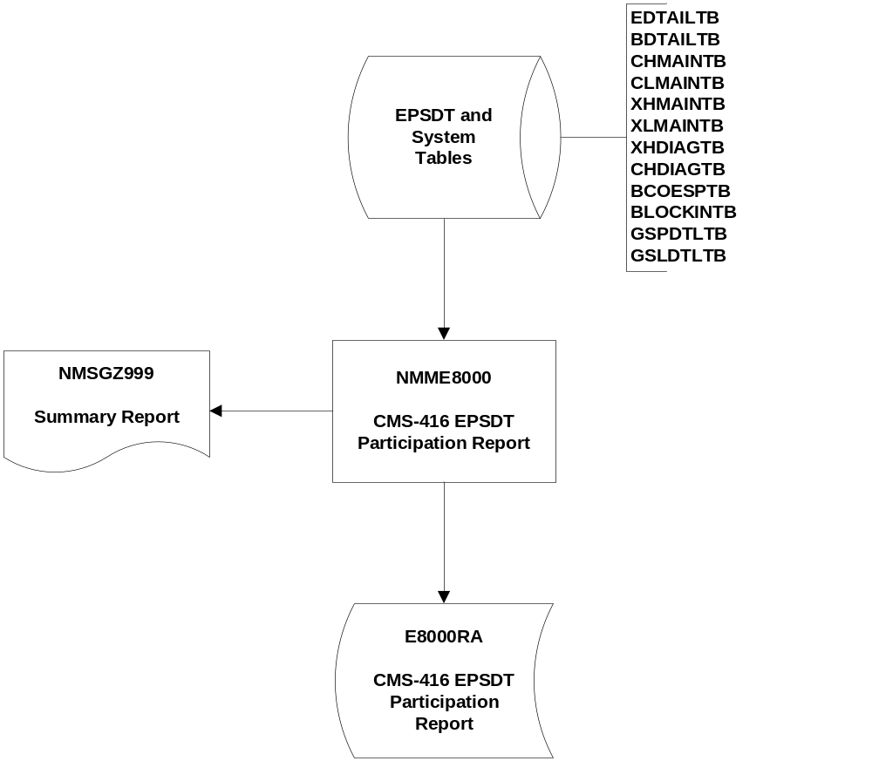
21.6.11 Identify Clients Over 28 Years Old – NMME9300

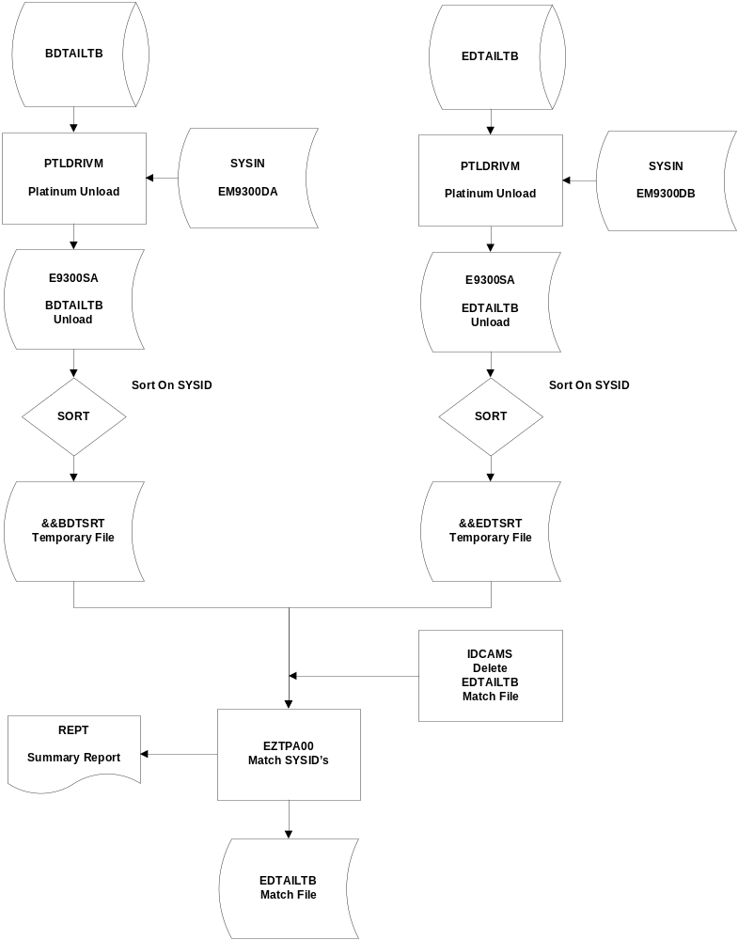
21.6.12 Delete Clients Over 28 From EPSDT Tables – NMME9400



